

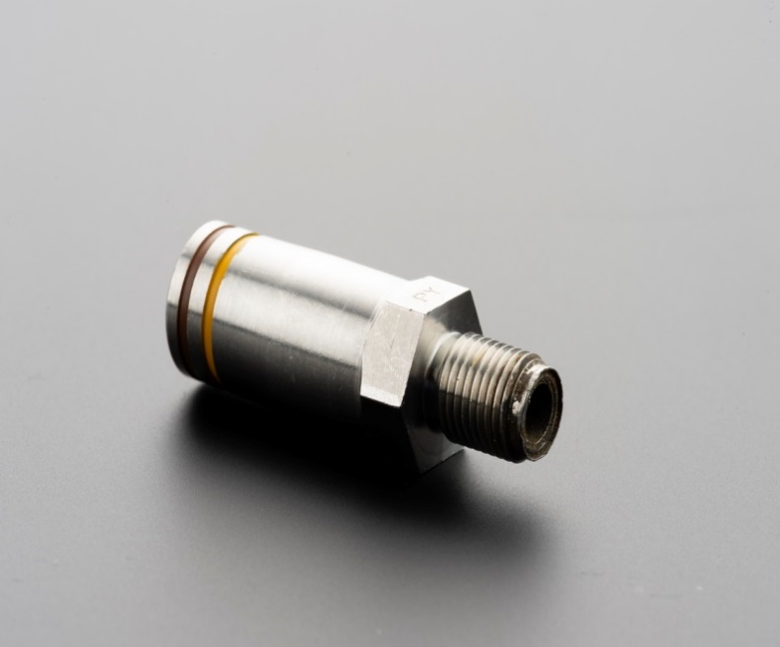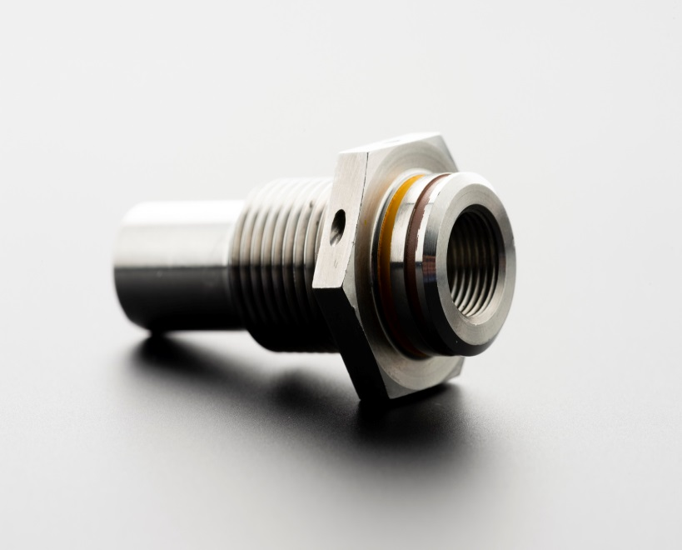

**DEFENSE**

**THROUGH BULKHEAD INITIATORS (TBI)**

Pyroalliance designs and manufactures a series of Through-Bulkhead Initiators (TBIs) for defense applications. TBIs are designed to convert a detonating input into an ignition function, typically to ignite the propellant of a Solid Rocket Motor. Tightness is guaranteed between upstream and downstream side of bulkhead, preventing any loss of pressure.

TBIs are a key component of the propulsion function reliability and safety.

Combined with other products from Pyroalliance, TBIs are part of pyro-chains for Solid Rocket Motors.

More generally, Pyroalliance delivers complete pyrotechnic chains adapted to its customers’ needs.

They are designed and manufactured under Pyroalliance design authority.

|  |  |  |
| --- | --- | --- |
| .Typical performances and features. | | |
| Operating time | < 5ms |
| Output energy | Range of 2300-2700J |
| Ignition mode | Detonating line / SAD |
| Size | Height : 46mm  Length : 17.5mm  Width : 15.5mm |
| Weight | < 50g |
| Reliability | 0.9999 @90% CL |
| Leak rate | Less than 10-5 ccs/sec under 1 bar after functioning |
| Operating temperature | Adapted to typical airborne military climatic environment |
| Life Time | Adapted to the mission and life profile |

**THROUGH BULKHEAD INITIATORS (TBI)**

**.Operating mode.**

When the upstream detonating transfer line is activated, the detonating signal is transmitted via the TBI from the donor detonating charge to the receptor detonating charge through a tight metallic barrier. The signal is then converted into combustion mode by the TBI ignition mix, to trigger the downstream igniter train. TBIs operate through a shock wave stemming from the detonating line.

TBIs belong to a pyrotechnic chain which ensures transition from a detonating signal stemming from a detonating transfer line or directly from a Safe & Arm Device (SAD) system into the deflagration of an ignition load, across a tight barrier.

**.Benefits.**

TBIs provide:

* An ignition function with detonating input
* Structural barrier preventing loss of pressure of downstream elements
* Mass savings through the reduced quantity of embedded electrical power
* Absence of primary explosives (making one single Safe & Arm Device at the beginning of the pyrotechnic chain sufficient)
* Reduced dispersion of ignition times
* High level of safety (EMC and lightning immunity)
* Architecture without any moving parts

* **.Applications.**
* Ignition of single pulse solid propellant motors

**Classification**

* UN Number: UN0368
* Explosive Class: 1.4S in storage & delivery configuration
* Not subject to any ITAR constraint

**.For more information.**

**Contact us:** **customer-info@pyroalliance.com**

*This document and its contents are property of Pyroalliance. It shall not be copied without Pyroalliance written consent. All rights reserved – © Pyroalliance 2025*

*Produced by the Communication Department of Pyroalliance - Photo credits : Pyroalliance & ArianeGroup*

OM%

Follow us on **LinkedIn**

**www.pyroalliance.com**

**Les Mureaux Plant - Headquarters**

139, Route de Verneuil - BP 2052

78132 Les Mureaux cedex – France

Tel. +33 (0)1 34 92 44 44

OM%

**SCAN ME**

**.pyroalliance.com**